Project Development Phase
User Acceptance Testing FSD – Incident Project
Implement Client Script & UI Policy (Incident)
Date | 1 October 2026
Team ID | SWTID-2026-4755
Project Name | Implement Client Script & UI Policy (Incident)
Maximum Marks | 4 Marks
1. Project-specific test context
Define positive and negative acceptance scenarios for the Incident implementation. This report is the closest direct adaptation of the UAT FSD report included in the supplied ZIP.
The project uses a ServiceNow Incident form and list with one High Impact Control UI Policy and three Client Scripts. The test focus below adapts the ZIP reference report type to the Incident project; it does not claim that a live execution was completed during report preparation.
2. Project metrics / equivalent parameters
S.No. | Parameter | Project-specific values / evidence
1 | Project Name | Implement Client Script & UI Policy (Incident)
2 | Project Description | Client-side controls for high-impact Incident routing, urgency, ownership validation, and State-edit safety.
3 | Project Version | Phase 5 UAT baseline — 1 October 2026
4 | Acceptance scope | Five UAT cases covering mandatory enforcement, successful save, reversal, list blocking, and form update.
3. Test scenarios and results
Test Case ID | Scenario | Test Steps | Expected Result | Actual Result | Status
UAT-001 | Mandatory enforcement | Impact High; Assigned To empty; submit. | Save blocked and Assigned To error shown. | Pending execution | Pending
UAT-002 | Successful save | Impact High; Assigned To selected; submit. | Incident saves successfully. | Pending execution | Pending
UAT-003 | Reverse condition | Change Impact High to Medium. | Assignment group no longer mandatory; Urgency editable. | Pending execution | Pending
UAT-004 | List edit blocking | Edit State directly in list. | Alert appears; State remains unchanged. | Pending execution | Pending
UAT-005 | Form-based update | Change State on form; click Update. | State update saves successfully. | Pending execution | Pending
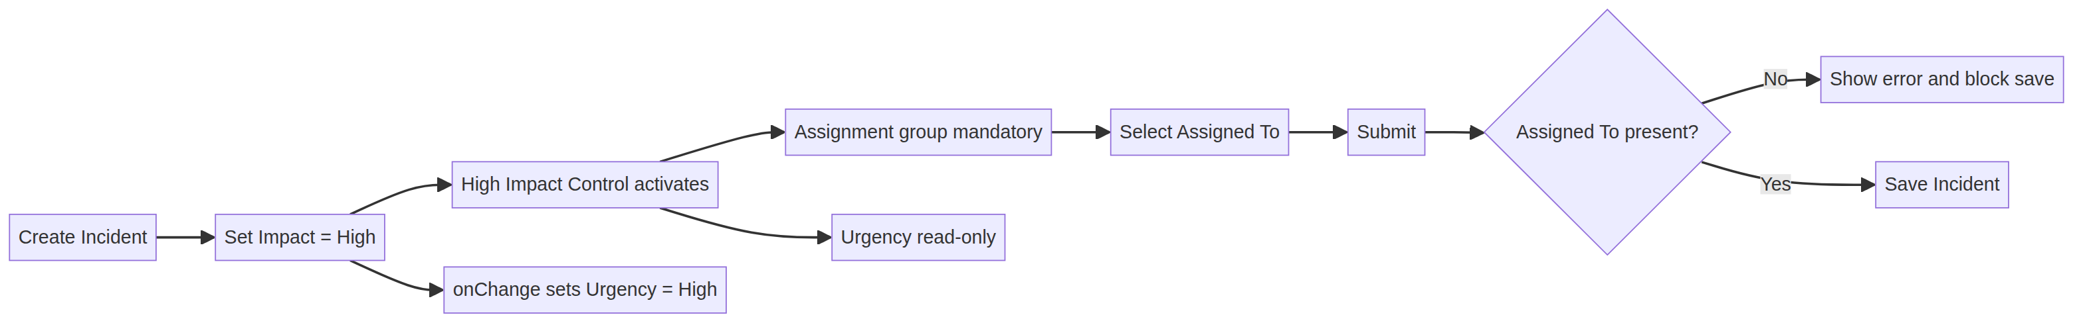
Original project-specific visual created for this Incident report.
4. Interpretation and evidence note
Formal approval should follow execution in the target ServiceNow instance. The supplied project PDF defines the expected behavior but does not provide live evidence.
5. Execution status
Status at report preparation: Pending execution in the target ServiceNow instance. The source project PDF defines the configuration and expected behavior, but does not include live screenshots, response-time logs, or execution timestamps. Record those artifacts against each test case before final sign-off.
6. Conclusion
This report provides a project-specific Phase 5 testing baseline for Implement Client Script & UI Policy (Incident). The selected scenarios verify conditional field behavior, urgency automation, save-time validation, list-edit protection, and form-based updates while preserving the traceability expected in the supplied reference reports.

